Lab 2 – Home Tasks – 24k0880

Task 1:
INCLUDE Irvine32.inc

.data
myByte BYTE 25h
myWord WORD 1234h
myDword DWORD 98765432h
myChar BYTE 'A'
myStr BYTE "Hello!",0

.code
main PROC
mov al, myByte
mov ax, myWord
mov eax, myDword
mov bl, myChar
mov edx, OFFSET myStr

call DumpRegs

exit
main ENDP
END main

Output:
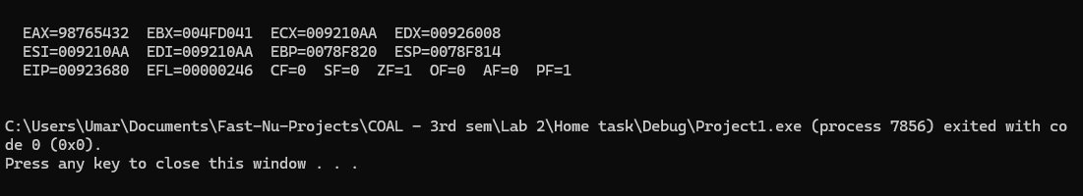

Task 2:

INCLUDE Irvine32.inc

.data
num1 dword 65

.code
main PROC
mov eax, num1
call writedec
call crlf
call writehex
call crlf
call writebin

;call DumpRegs

exit
main ENDP
END main

Output:
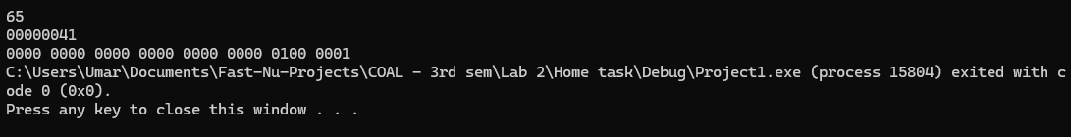

Task 3:
INCLUDE Irvine32.inc

.data
num1 dword 24
num2 dword 12
num3 dword 3
p1 dword ?
msg byte "Final answer for ((num1%4)/num3)*(num2 + num3*3) is: "

.code
main PROC

; num1%4
mov eax, num1
xor edx, edx
mov ebx, 4
div ebx
mov eax, edx
mov p1, eax
call writeint

call crlf

;(num1%4)/num3
mov ebx, num3
xor edx, edx
div num3
mov p1, eax
call writeint

call crlf

;num3*3
mov eax, num3
mov ebx,3
mul ebx
call writeint

call crlf

;num2 + num3*3
add eax, num2
call writeint

call crlf
call crlf

mov edx, offset msg
call writestring

;((num1%4)/num3)*(num2 + num3*3)
mov ebx, p1
mul ebx
call writeint
call crlf

exit
main ENDP
END main

Output:
